Enterprise AWS Infrastructure Deployment

1. Resource Organization:

Use proper naming conventions

Organize resources using tags

2. Networking Layer (VPC Design):

Create a VPC

Create at least: 2 Public Subnets (different Availability Zones), 2 Private Subnets (different Availability Zones)

Configure: Internet Gateway (IGW),NAT Gateway , Route Tables

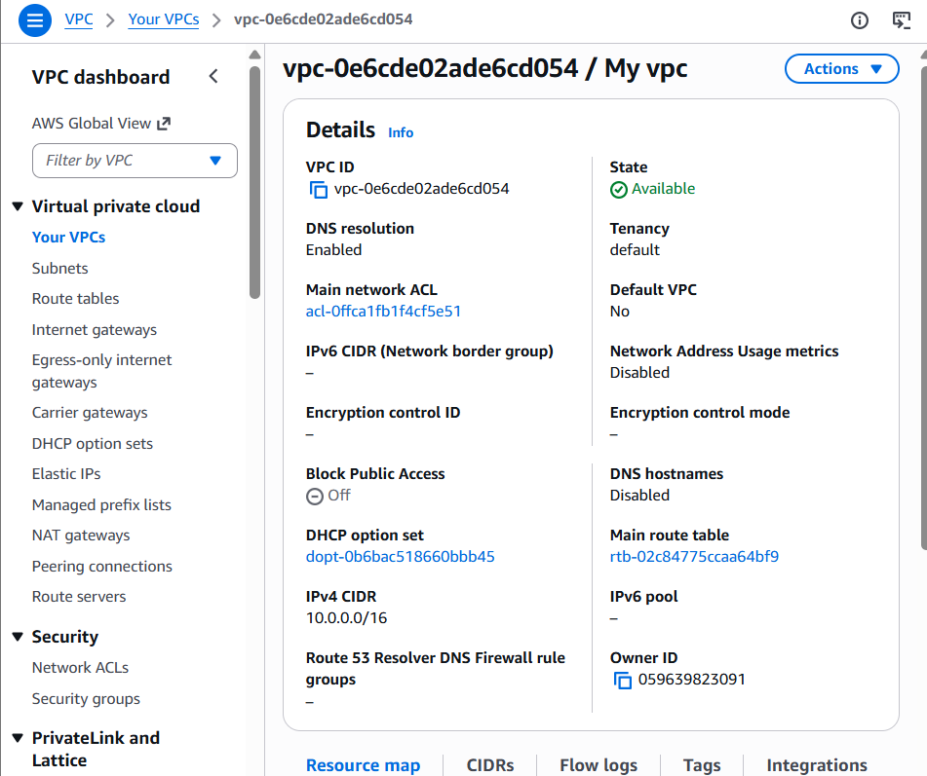
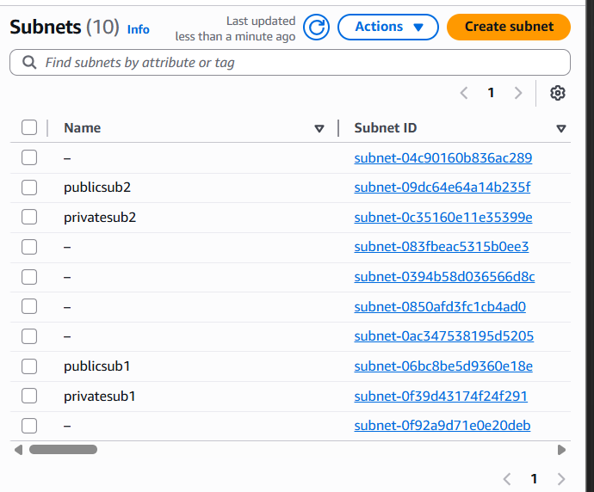
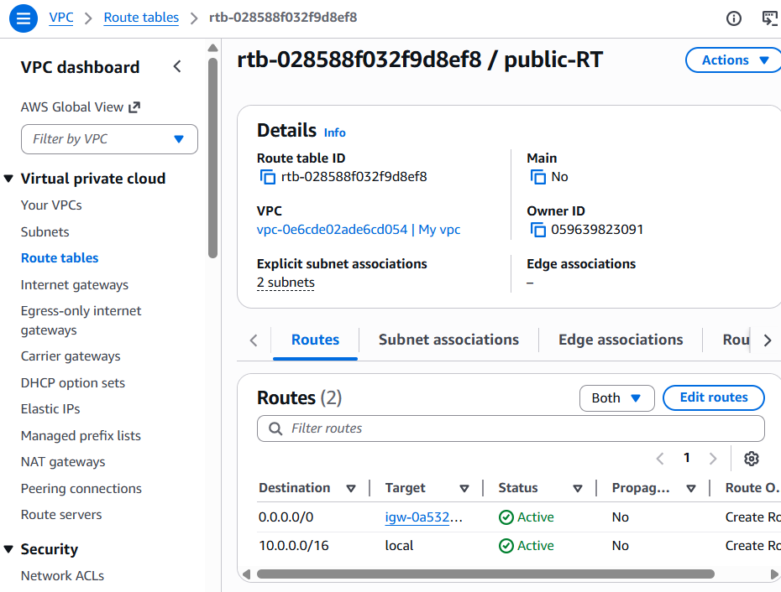
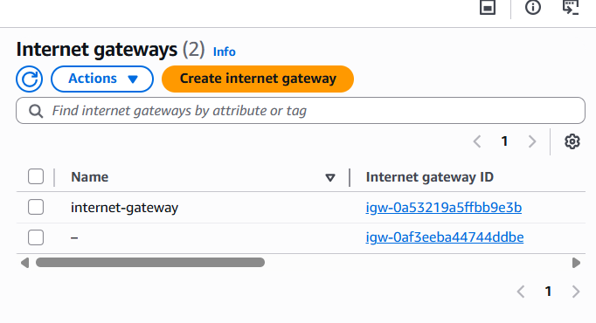

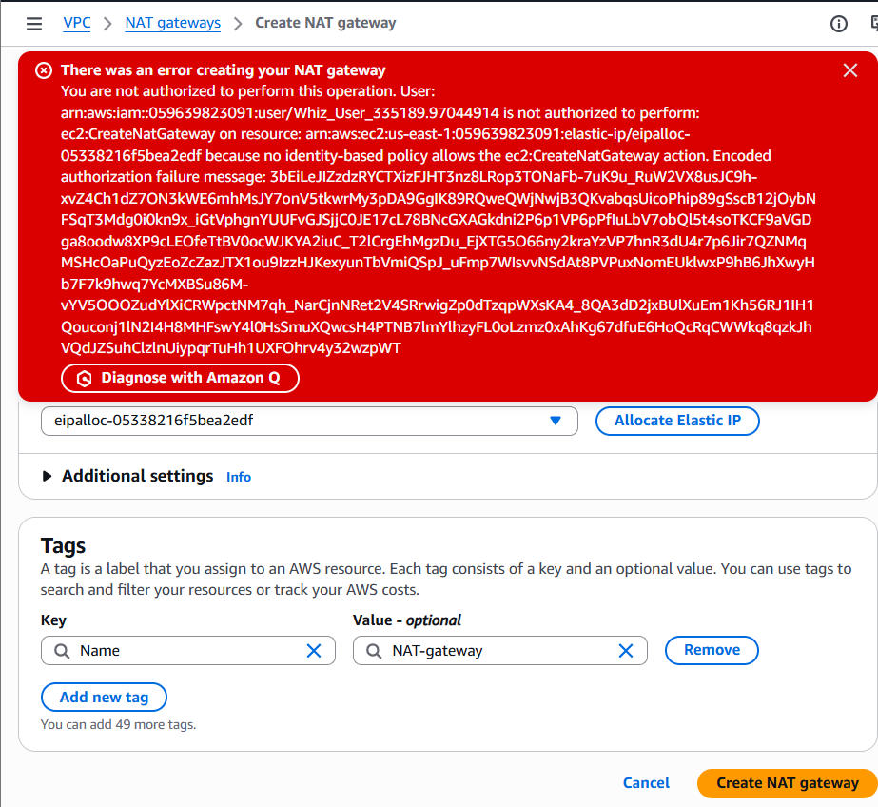

3. Compute Layer:

Launch at least 2 EC2 instances in private subnets

Install a Web Server (Nginx / Apache)

Ensure servers are reachable through Load Balancer only
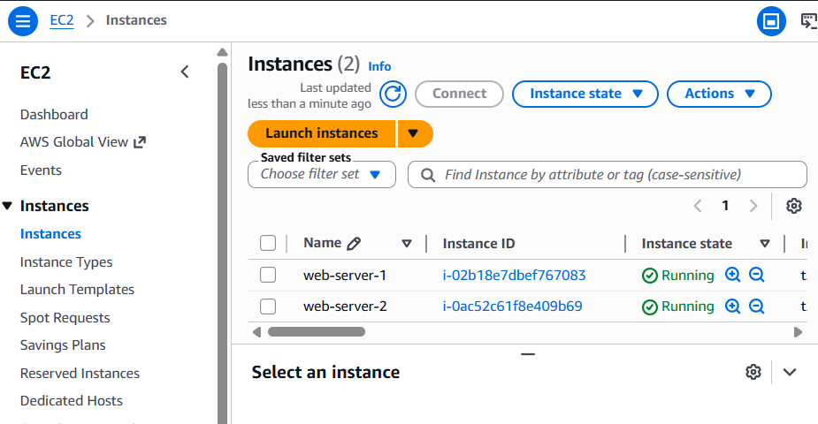

4. Load Balancing:

• Configure an Application Load Balancer (ALB)

• Distribute traffic across EC2 instances

• Health checks must be enabled

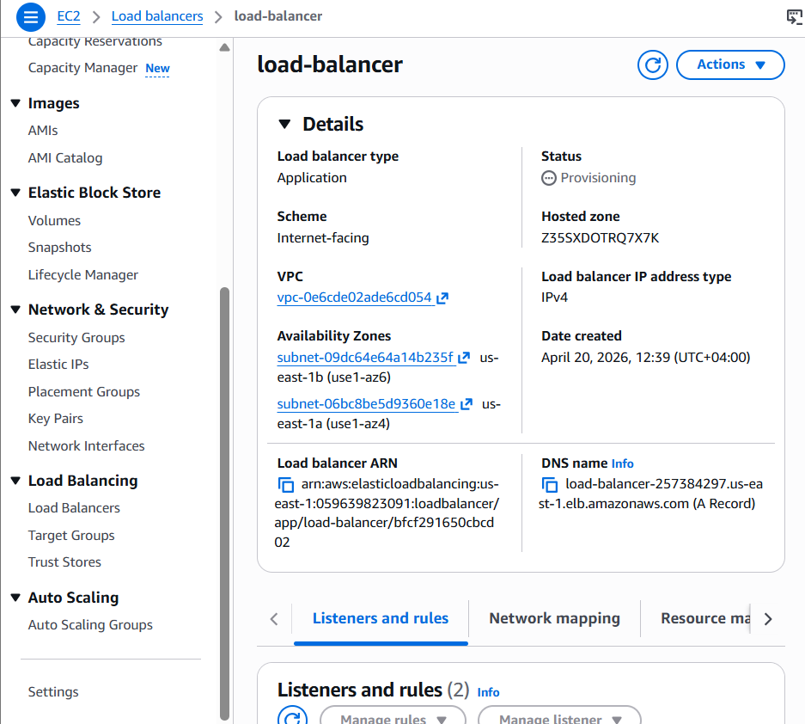

5. Data Layer :

• Deploy RDS (MySQL / PostgreSQL)

• Disable public access

• Allow access only from application layer

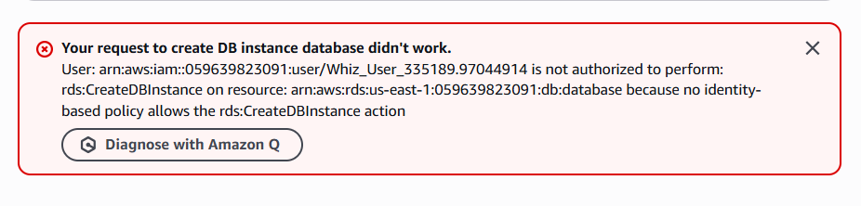

6. Security:

• Configure: Security Groups, NACLs (optional)

• Use: IAM Roles (no hardcoded credentials) , AWS Secrets Manager or Parameter Store

• Apply: Least Privilege Principle

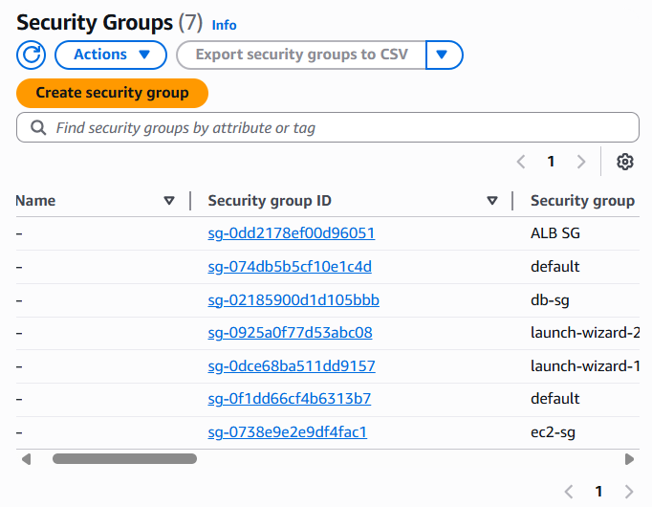
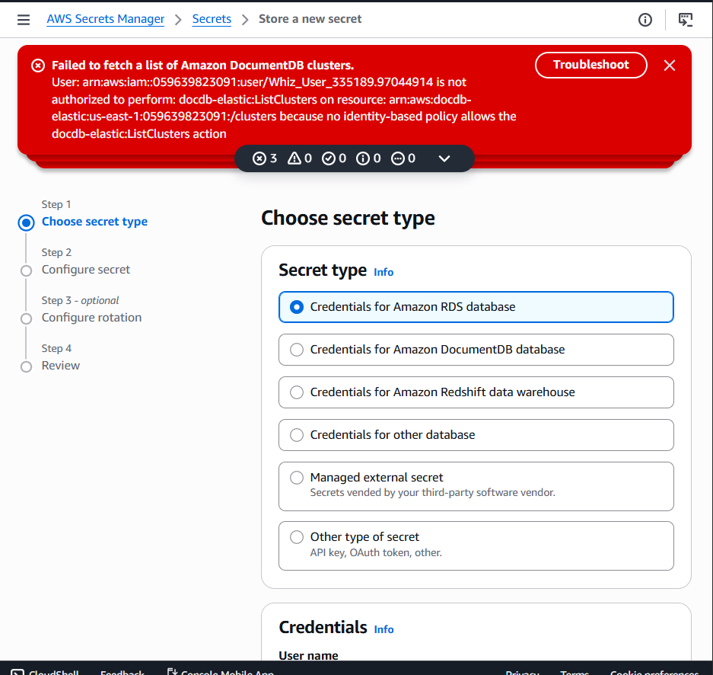

7. Monitoring & Logging:

• Enable:

CloudWatch Metrics

CloudWatch Logs

• Create at least one Alert (e.g., CPU utilization)
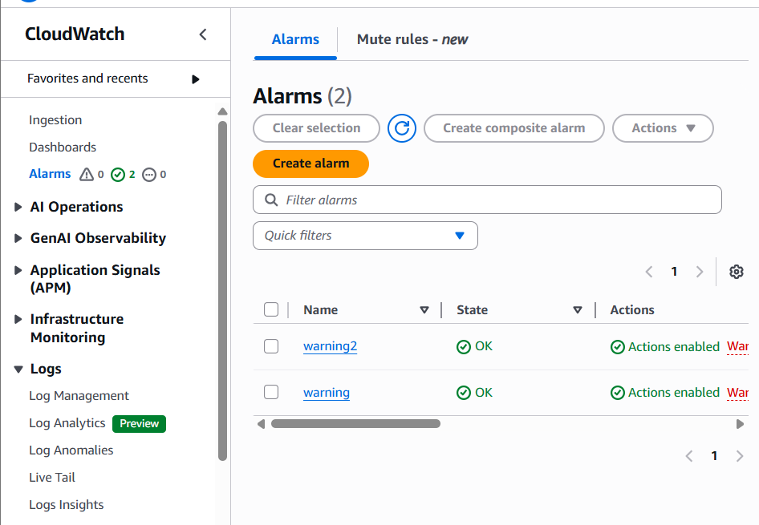

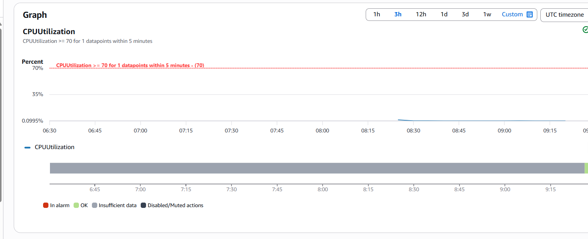
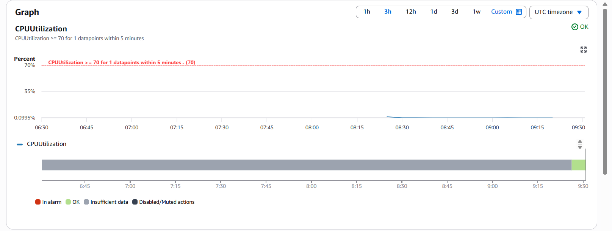

8. Automation:

Deploy infrastructure using: CloudFormation

OR

Terraform

